SETU Creative Computing Summer Camp

3d sculpting with Blender

- to install the software we will use, head to blender.org and click the "Download Blender" button.

- proceed with the installation and launch Blender with the Desktop icon.
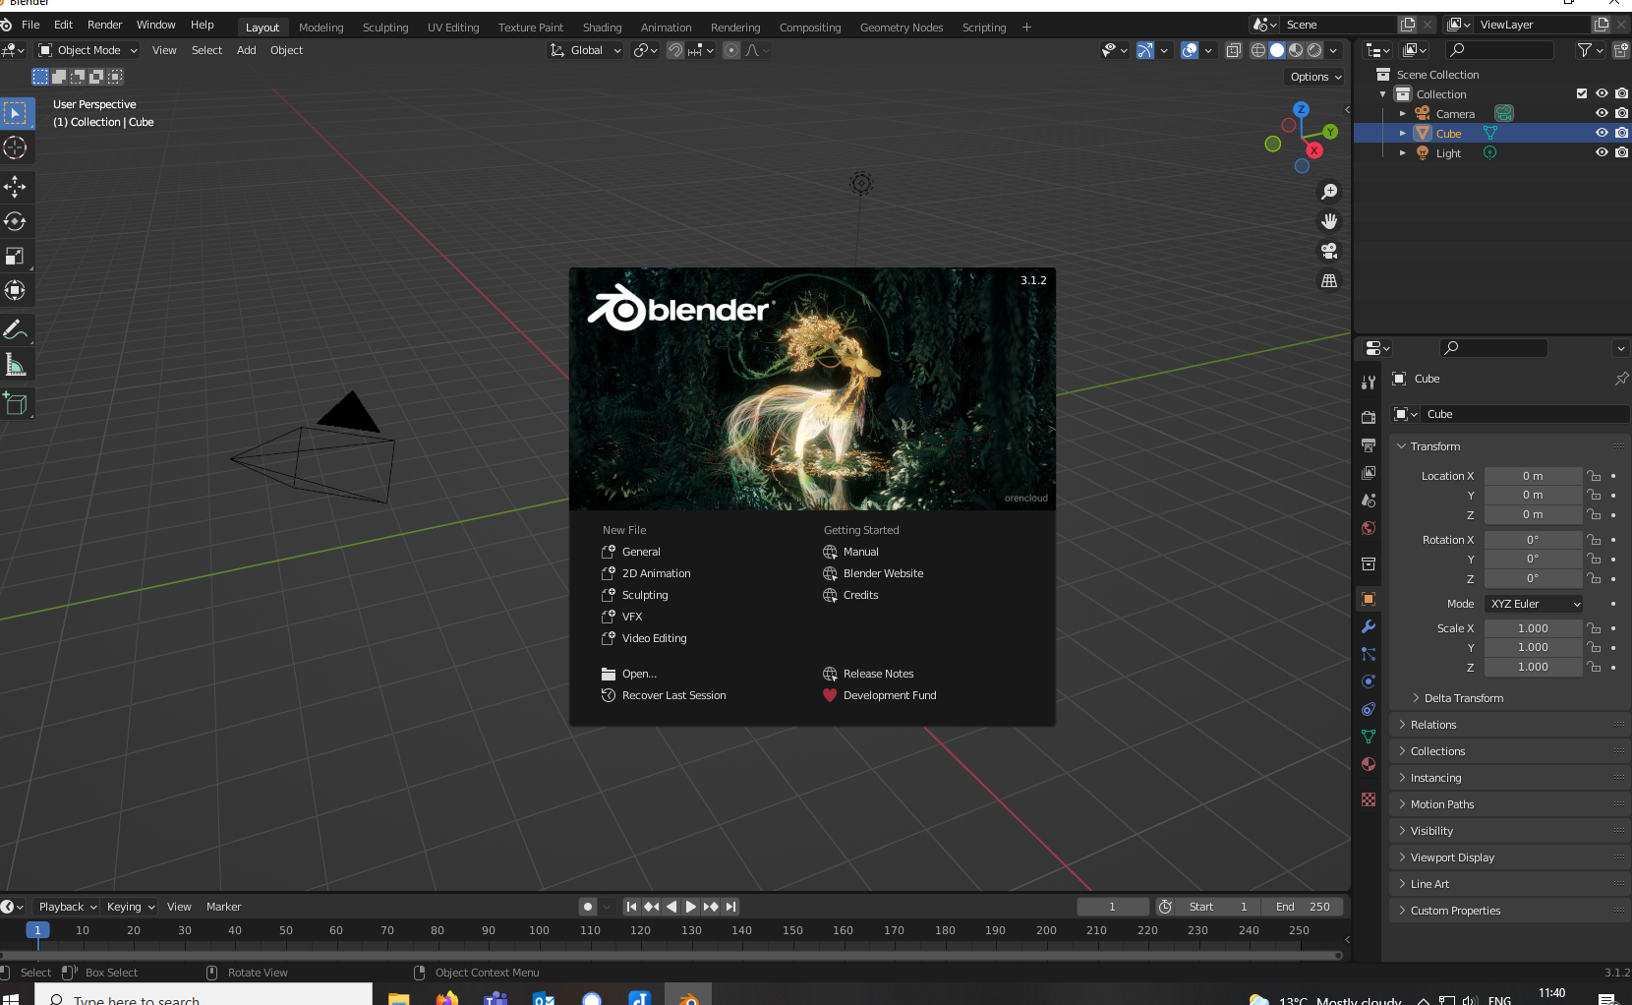

- create a "General" New file or use the top toolbar File > New > General

- You should see a grid and a cube in the middle of the space like so:

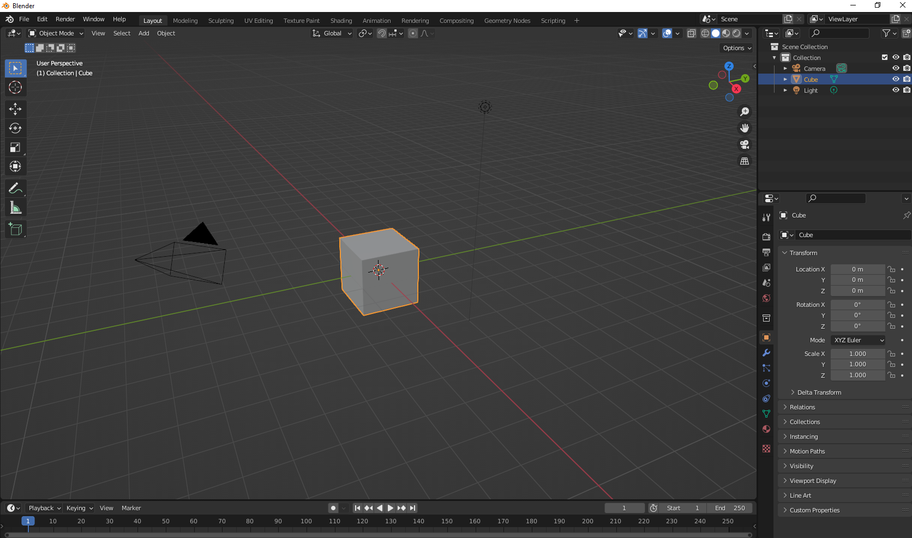

Moving around the scene

- Blender is a 3d environment so changing perspectives is quite important, you want to be able to see all sides of the cube or sphere or character you are building, front, side, from the top, from the bottom. The easiest way to pan around the object is to click and hold the scroll wheel of your mouse and move the mouse around. You are now changing your view around the object. Just like if you were taking a picture of somebody, you can take a picture of them face on, from a side, or even behind them.

- The other option is to use the numbers on the Numpad. Press the different Numpad numbers to change the views around the object.
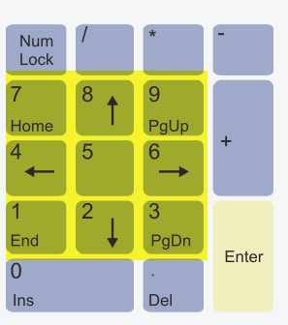

- There is a third way of panning around the object, locate the tilde key on the top left of your keyboard, beside 1, above tab and below Esc you'll see a key that looks like the image below. by pressing that key, on-screen options will appear to let you move around the object.

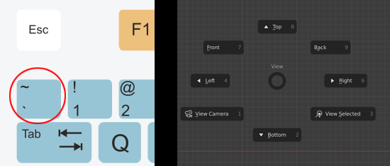

- Try using the scroll-wheel to zoom in and out (get closer or be further away)

- Try holding shift and clicking and holding the scroll wheel down. That combination should let you move laterally to the object in the same plane.

Getting started with sculpting

There are many many ways of creating and editing 3D objects in Blender. The most fun way is using the sculpting tools. Just like you would with clay, we can manipulate Blender objects by pinching, grabbing and smoothing the surfaces. Follow these steps to get started:
- add a cube to the scene:
In the 'Object Mode' add a Cube by clicking on Add > Mesh > Cube or using the shortcut SHIFT + A then selecting Mesh > Cube
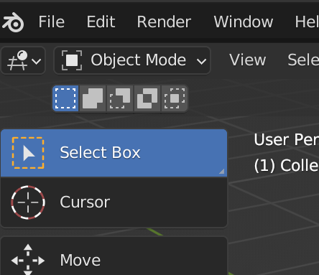
You should see a Cube in your collection list in the top right of the Blender interface like so:
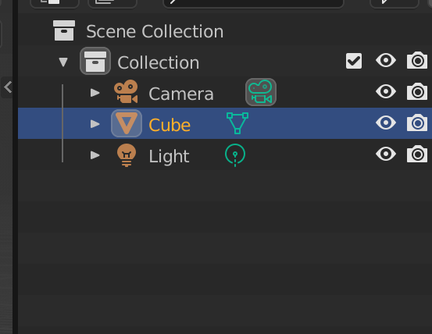

- add a modifier to the cube to add more faces:
With the Cube selected, find the Modifier tab in the object properties window in the bottom right corner of the interface
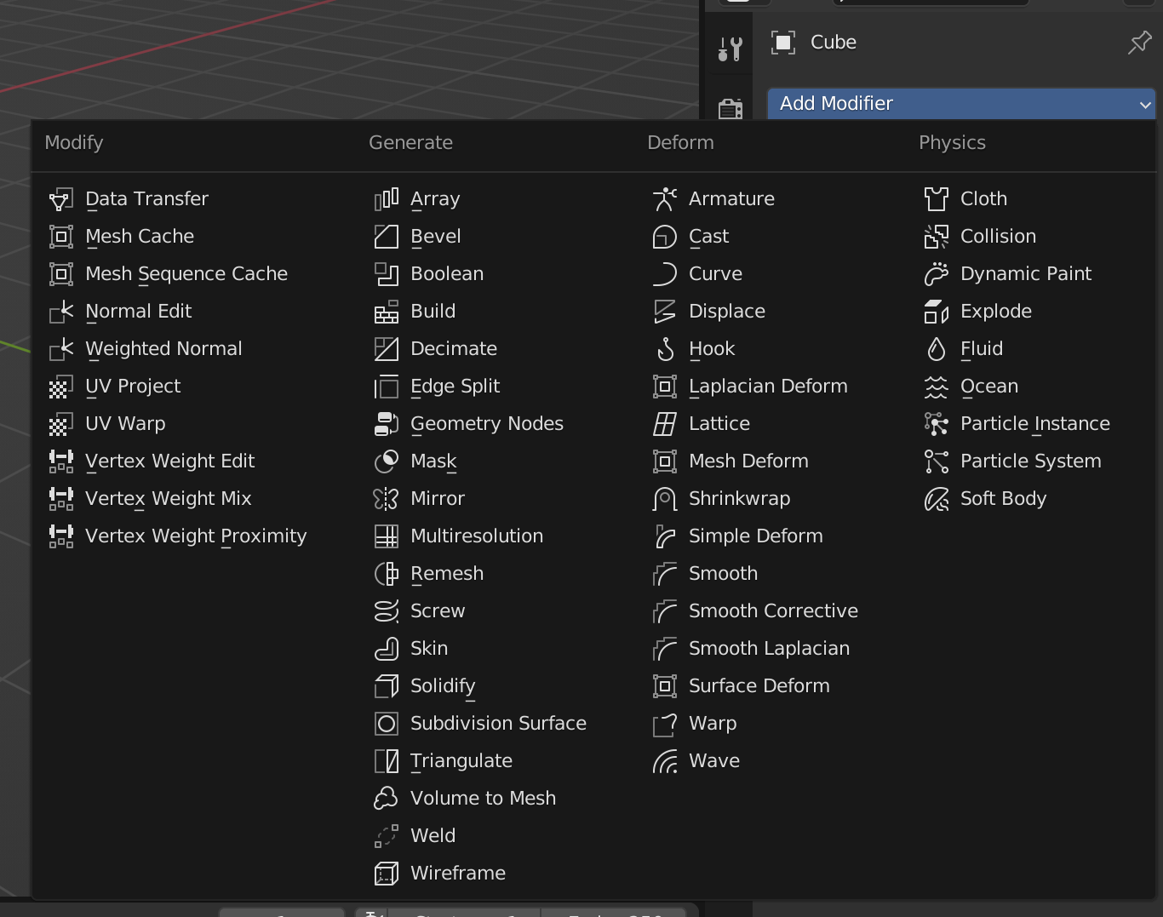

- Out of the big list of Modifiers, select the Subdivision Surface modifier and you should now have a new object property box in the bottom right portion of your window like so:
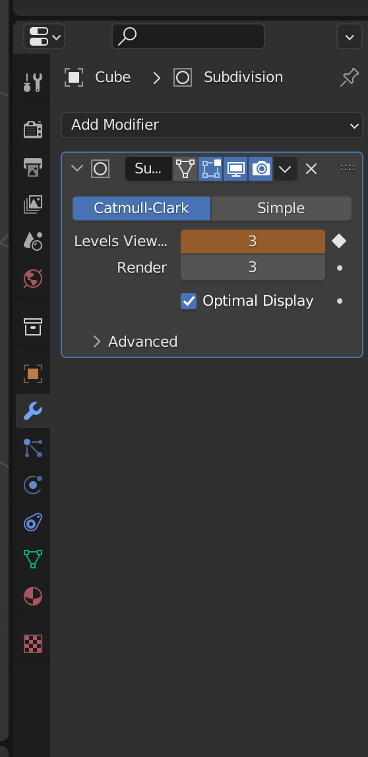

- Set the Levels Viewport option to 3 and set the Render option to 3 also. Your cube should now look more like a kind of golf ball:
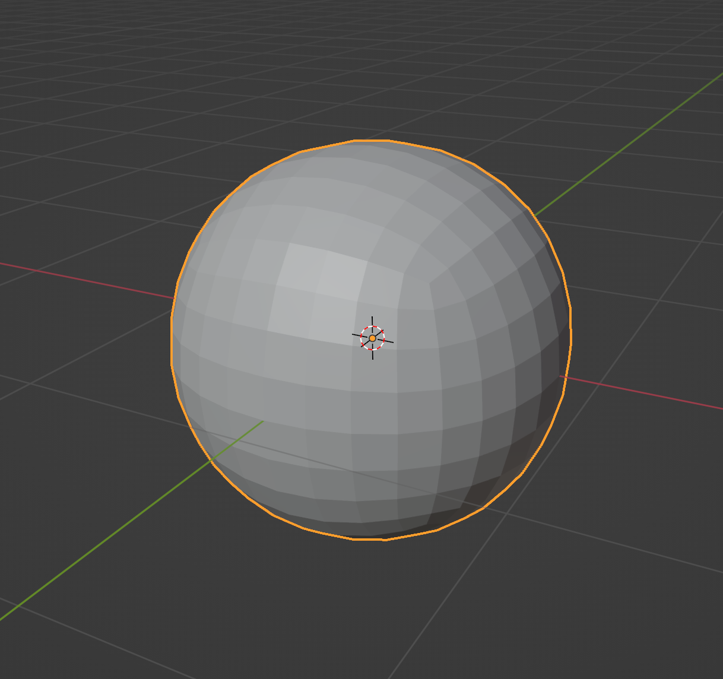

- For the moment, we are only getting a preview of what the modifier will do. Before we move on, we must apply it. To apply the Modifier look for the drop-down menu button that is in the modifier window, beside the X mark. In that drop-down menu, select Apply or use the keyboard shortcut CTRL + A
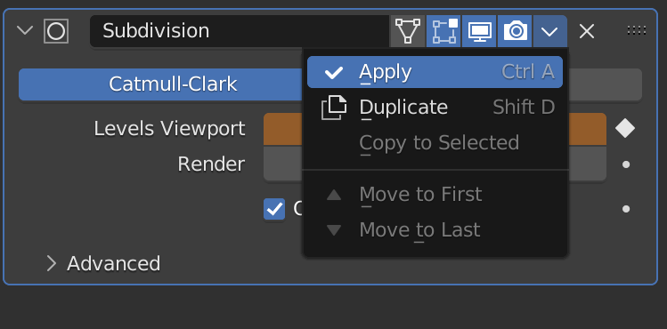
- All our setup is done now, we can begin sculpting! In the top right of the window, change Blenders mode to Sculpt Mode
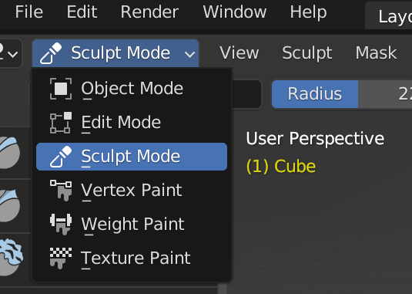
You should now see a bunch of icons all along the left of your screen. It is not very clear what each of these do until you hover over that toolbar and expand it out by clicking and dragging out the right side. You should be able to go from this view:

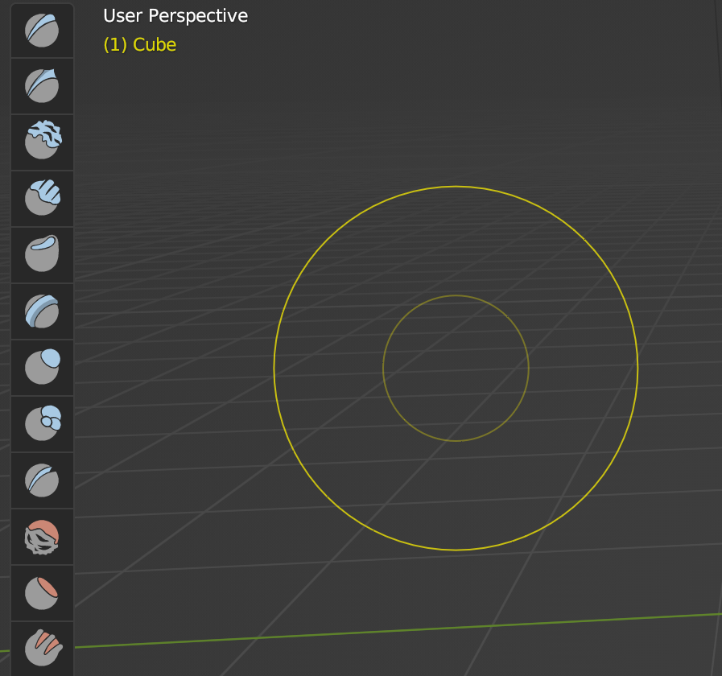

to this one:
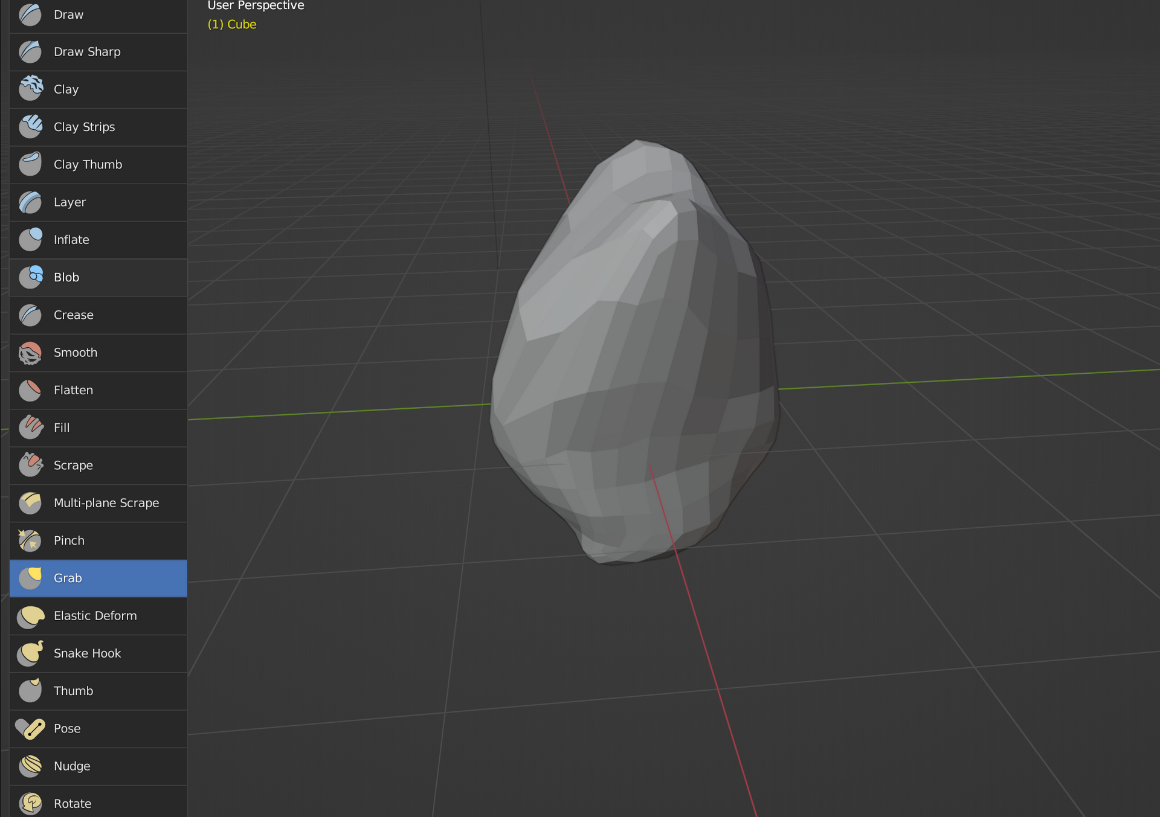

Now all the tools have a name, much easier to know what is what.
All of these tools will modify our objects in different ways, some will score the surface, other will let you totally reshape the object. Have a go with some of them, see what you can make. Just as it is with any artistic process, it is really important (and often quite fun) to experiment and make tests.

You can always undo your last action by using CTRL + Z and you should also add more shapes to your workspace (by repeating steps 1, 2 and 3 of this section) if you want to keep some shapes you've sculpted. Here are three bizarre shapes I made quickly only by using the Grab tool.

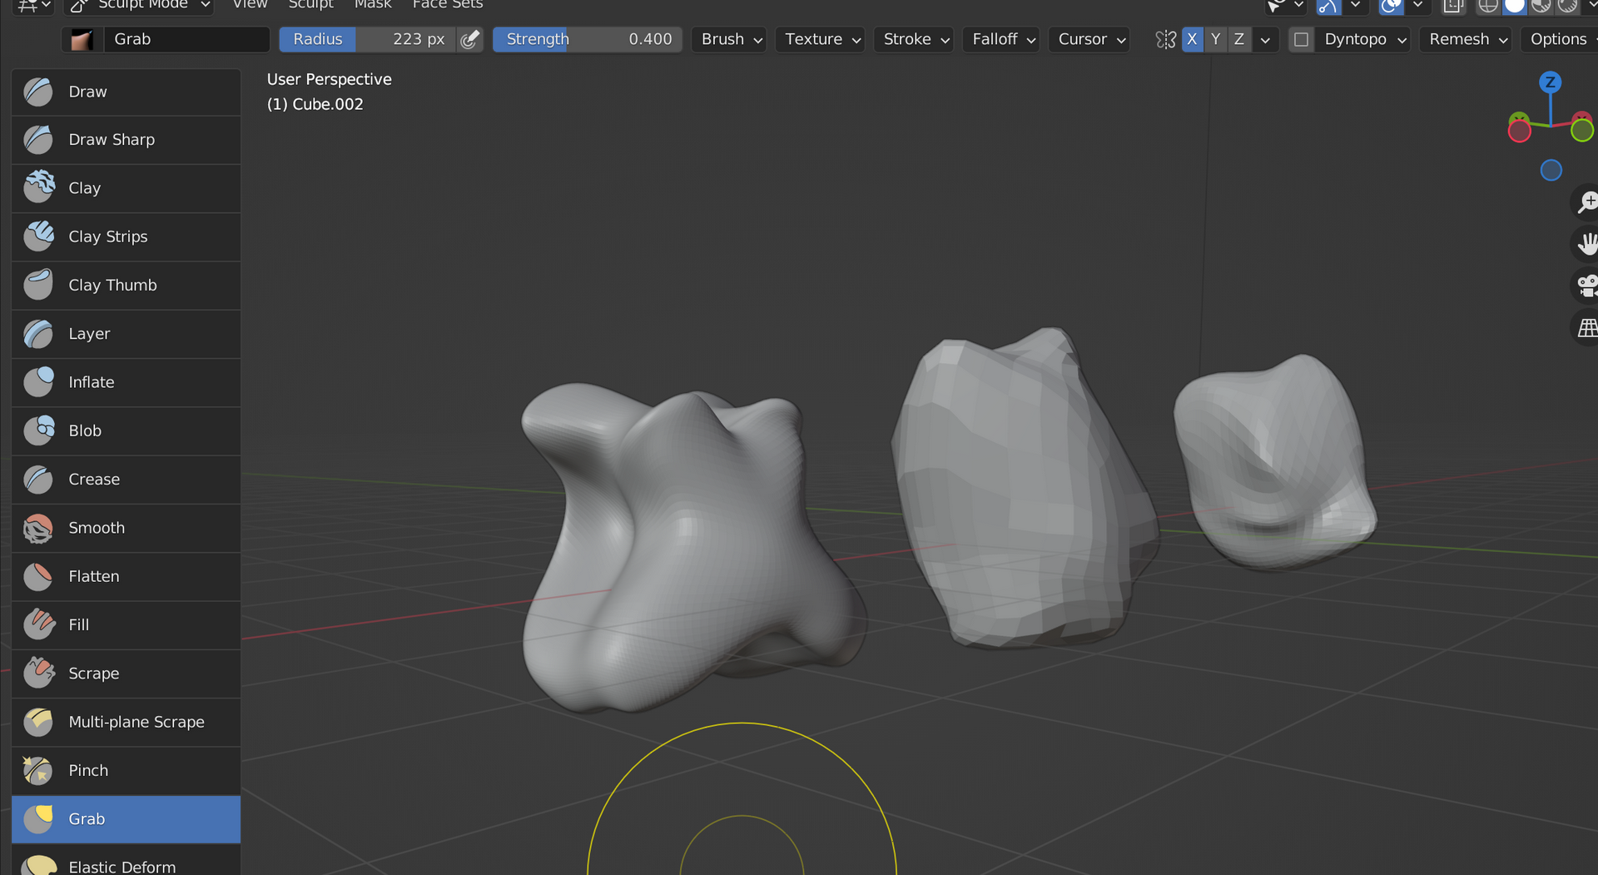

1.3 Sculpting tips and tricks
You are encouraged to experiment now and get a feel for the processes of sculpting in Blender.
- I recommend that you use the Grab and Smooth tools the most. The other tools can produce nice results too, but the grab tool is the easiest to get started with.
- Setting the size of your grab tool is very important. If you make your grab tool very large, you'll 'move' a lot of the material, if you set it to be small, you'll be much more precise. You're going to be constantly changing the size of your tool, so it can be helpful to remember the short key F which will let you quickly change the size of your tool on the go.
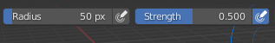

- Using symmetry is a really powerful option in Blender. Most animals and humans are symmetrical in our body compositions. From our spines, we have symmetrical features radiating outwards. Two arms, two legs, two hips, etc. When sculpting a face or a body-like feature, the symmetry modes in Blender can really help to produce a 'believable' or 'symmetrical' model.
Toggle the symmetry on one (or more) axis by locating the buttons pictured below:
